OBJECTIVE: The primary objective is to analyze the performance of the supply chain and identify key metrics such as manufacturing cost ,total cost, total products sold , most selling product , defect rate , shipping cost , and more . The analysis would be visualized through a comprehensive Power BI dashboard.

Which includes a step called as “ETL” where E- refers to extract data from data sources T – Refers to transform (data processing , data cleaning) L- Refers to load (for analysis)

1. STEP(1) : EXTRACTION OF DATA

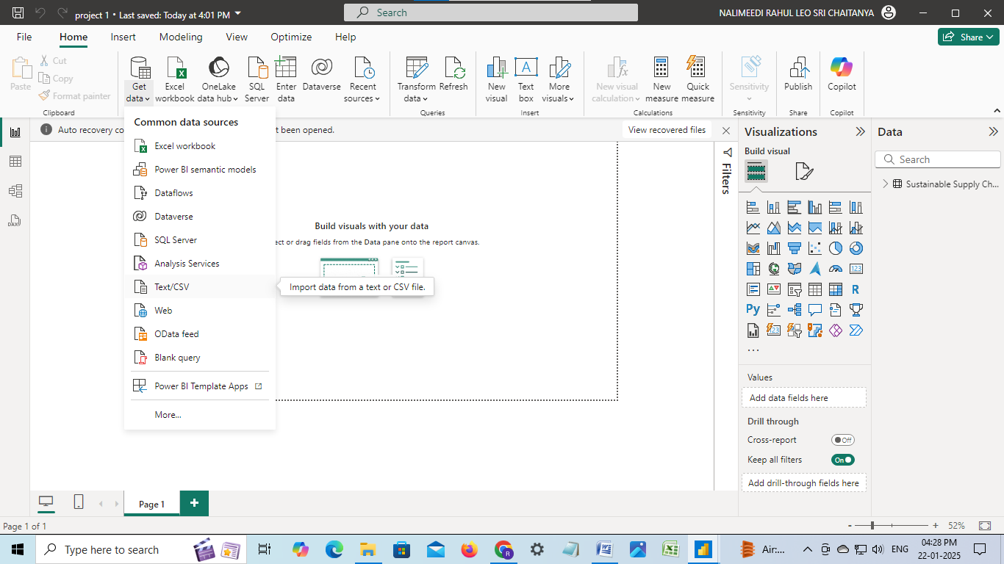

1. STEP(2) : LOAD THE DATA

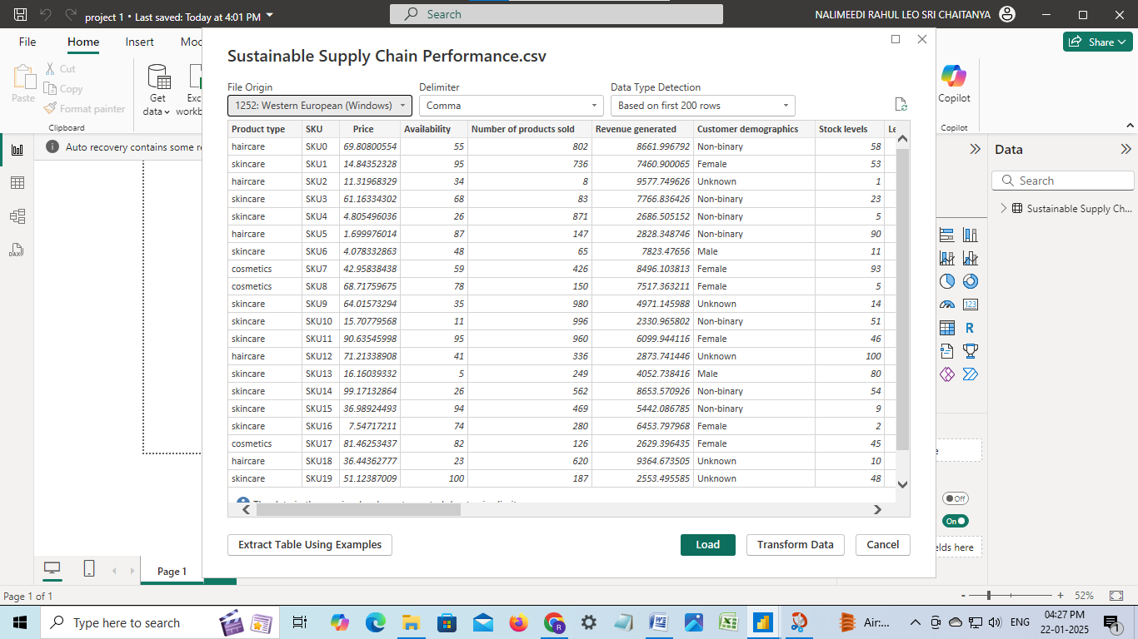

1. STEP(3) : THE DATA HAS BEEN LOADED

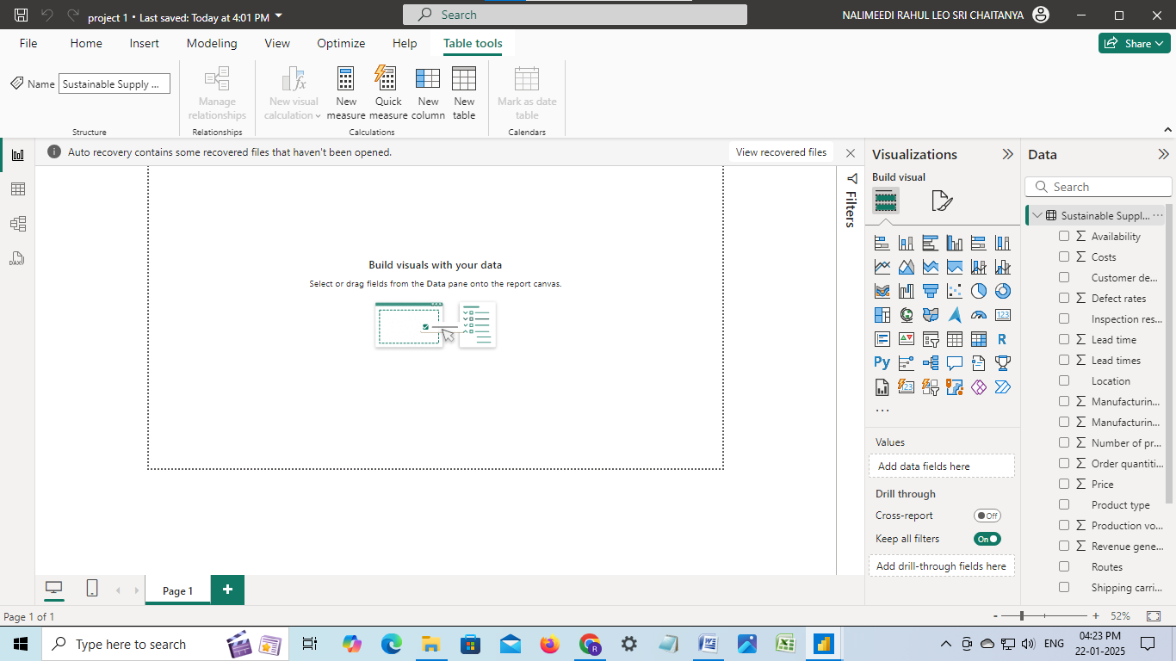

1. STEP(4) : GO TO REPORT VIEW ( HELPS IN VISUALIZATION)

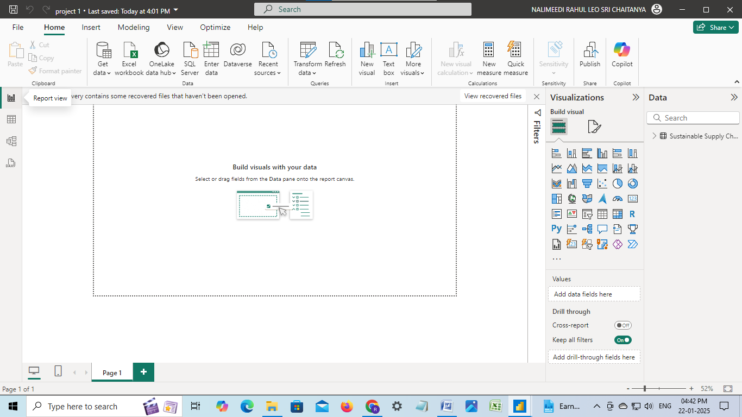

1. STEP(5) : CLICK ON TRANSFORM DATA OPTION TO TRANSFORM THE DATA

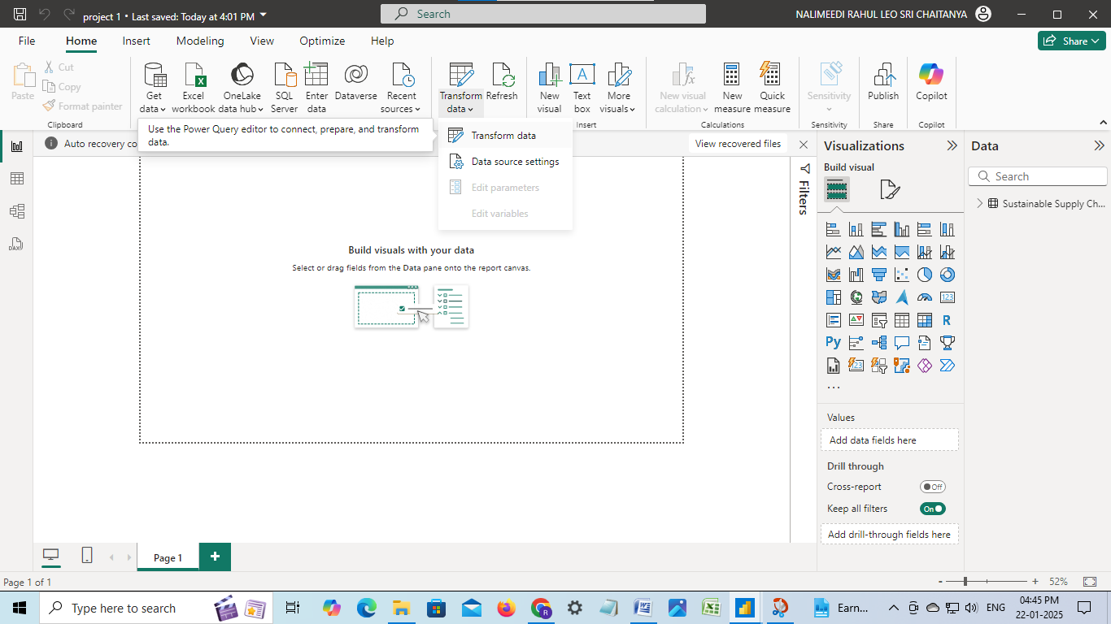

1. STEP(6) : START TRANSFORMING THE DATA ACCORDING THE SPECIFIC DOMAIN

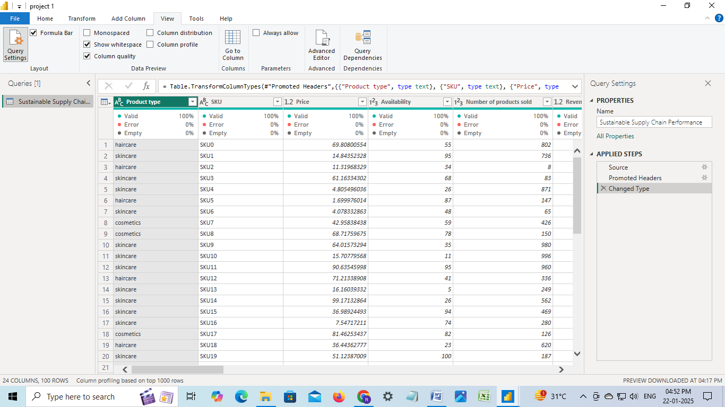

STEP(7) : WE HAVE A LIST OF TABLE DATA WE HAVE TO LIST OUT THEM ACCORDINGLY

Inventory Table:

1. Product type

2. SKU

3. Availability

4. Number of products sold

5. Customer demographics

6. Stock levels

7. Lead times

8. Order quantities

9. Lead time

10. Revenue generated

Manufacturing table

1. Product type

2. SKU

3. Production volumes

4. Manutacturing lead time

5. Manufacturing costs

6. Inspection results

7. ⁠ defect rates

Supplier Table

1. Supplier name

2. Location

3. Lead time

4. transportation modes

5. Routes

Supply chain table

1. Product type

2. SKU

3. Price

4. Availability

5. Number of products sold

6. Revenue generated

7. Customer demographics

8. Stock levels

9. Lead times

10. Order quantities

11. Shipping times

12. Shipping carriers

13. Shipping costs

14. Supplier name

15. Location

16. Lead time

17. Transportation modes

18. Routes

1. STEP(8) : ARRANGE THE DATA IN INVENTORY TABLE

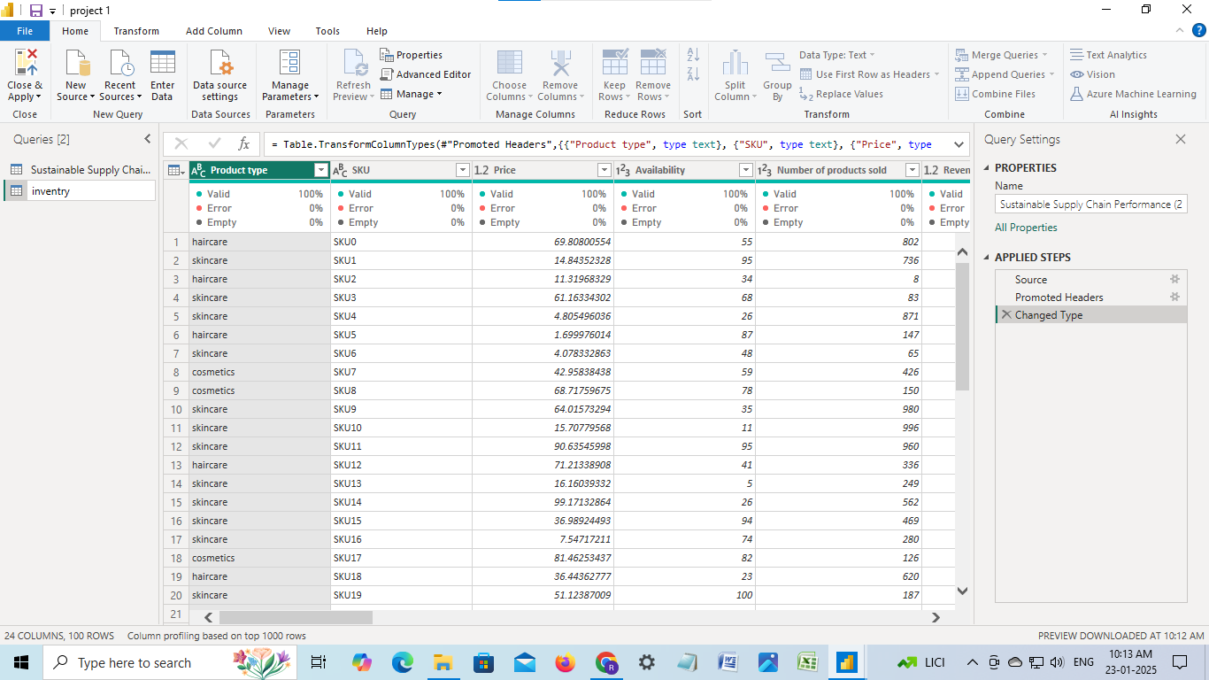

1. STEP(9) : ARRANGE THE DATA IN THE MANUFACTURING TABLE

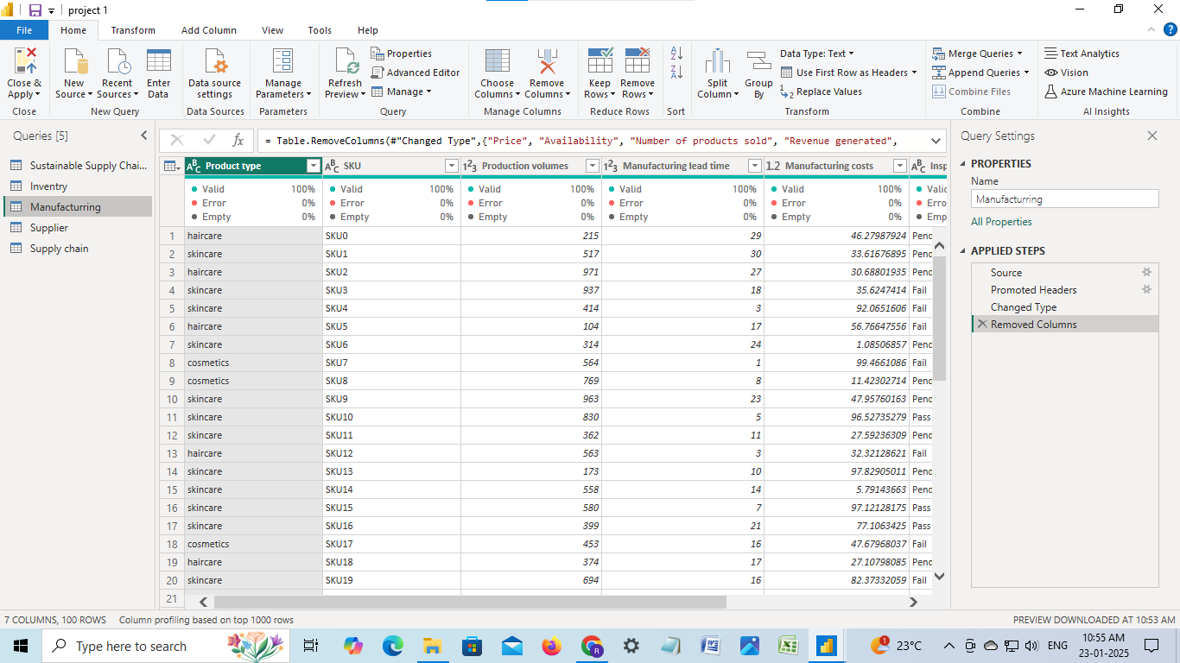

1. STEP(10): ARRANGE THE DATA IN THE SUPPLIER TABLE

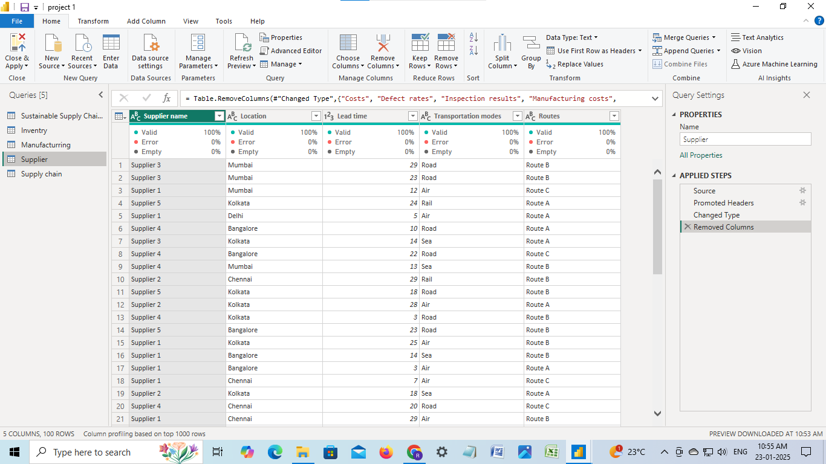

1. STEP (10) : ARRANGE THE DATA IN SUPPLY CHAIN TABLE

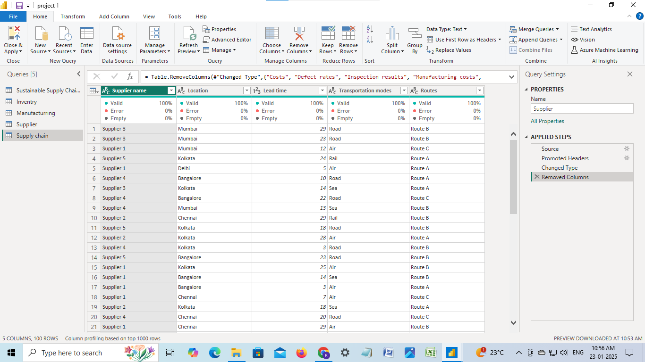

1. STEP (12) : THE FINAL STEP AND THE IMPORTANT STEP MAKE SURE TO SAVE THE DATA

